1. 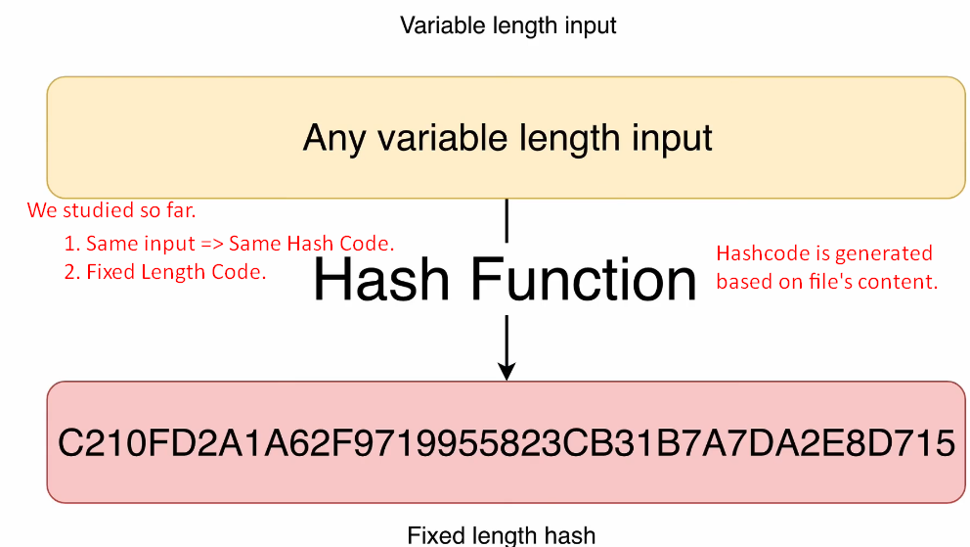
2. 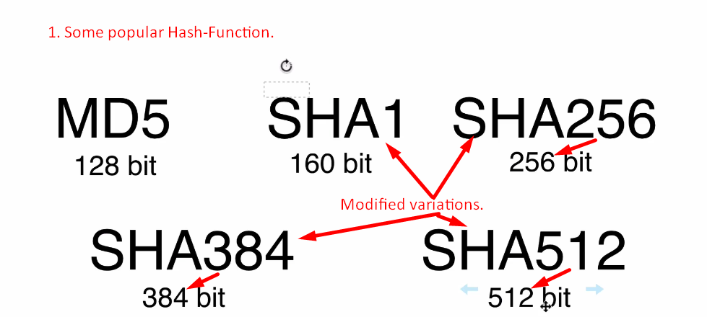
3. 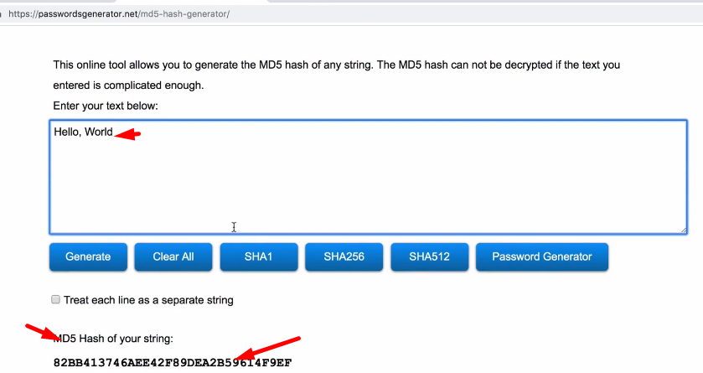
4. **In Next Lec**:
   1. Command line utility to create SHA1 Hash Code.